MUSIQue4U Program Manuel

Thank you for being interested for using the MUSIQue4U media database program. MUSIQue4U is an application that is to help you manage your *virtual* music and video files. You can add, modify, or delete your media, put them into playlists, then search and sort it accordingly to its specification just like any other music programs.

To get started, you will need to create an instance of the MUSIQue4U object, which is already done for you in MusiqueRunner class. Found at MUSIQue4U/src/MusiqueRunner.java.

Screenshot:

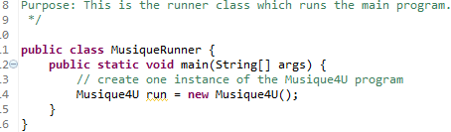

When executing the following program, it creates an instance of the Musique4U object which runs code in its initializer method which makes the application itself automated. When you have done this, you should see the following.

What you see should be similar to this,

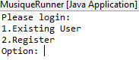

Now, you have launched the application successfully. Additional help will be given on the prompt where you are likely to need it.

If you do not see something similar to the above screen when starting the program, please make sure that you have the latest version of Java installed, preferably Java 6 and up which can be downloaded at <https://www.java.com/en/download/>

You may also need an IDE to run this code if you have limited command-line knowledge. You can download an IDE such as JGrasp here: <http://www.jgrasp.org/>

For support, you can submit a ticket at <https://github.com/SunxLite/MUSIQue4U/issues>